Database 환경

- 개요
  - 데이터베이스 기본정보
- IP : 127.0.0.1 (localhost)
- SID : xe
- ID : hr
- Password : a1234

  - 테이블 정보
- 테이블 개수 : 7개
- COUNTRIES(국가), DEPARTMENTS(부서), EMPLOYEES(사원), JOBS(업무), JOB_HISTORY(업무 이력), LOCATIONS(위치), REGIONS(지역)

- Entity-Relation Diagram
Sample로 사용하는 HR(Human Resource) 스키마의 정보는 아래와 같습니다.

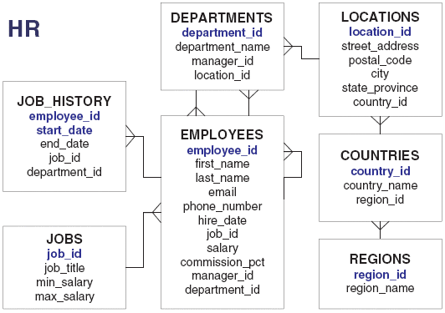

- Table Descriptions
테이블에 대한 상세 정보는 아래와 같습니다.

Table COUNTRIES (국가)
Name Null? Type
------------------- ---------- ----------------------
COUNTRY_ID NOT NULL CHAR(2)
COUNTRY_NAME VARCHAR2(40)
REGION_ID NUMBER

Table DEPARTMENTS (부서)
Name Null? Type
------------------- ---------- ----------------------
DEPARTMENT_ID NOT NULL NUMBER(4)
DEPARTMENT_NAME NOT NULL VARCHAR2(30)
MANAGER_ID NUMBER(6)
LOCATION_ID NUMBER(4)

Table EMPLOYEES (사원)
Name Null? Type
------------------- ---------- ----------------------
EMPLOYEE_ID NOT NULL NUMBER(6)
FIRST_NAME VARCHAR2(20)
LAST_NAME NOT NULL VARCHAR2(25)
EMAIL NOT NULL VARCHAR2(25)
PHONE_NUMBER VARCHAR2(20)
HIRE_DATE NOT NULL DATE
JOB_ID NOT NULL VARCHAR2(10)
SALARY NUMBER(8,2)
COMMISSION_PCT NUMBER(2,2)
MANAGER_ID NUMBER(6)
DEPARTMENT_ID NUMBER(4)

Table JOBS (업무)
Name Null? Type
------------------- ---------- ----------------------
JOB_ID NOT NULL VARCHAR2(10)
JOB_TITLE NOT NULL VARCHAR2(35)
MIN_SALARY NUMBER(6)
MAX_SALARY NUMBER(6)

Table JOB_HISTORY (업무 이력)
Name Null? Type
------------------- ---------- ----------------------
EMPLOYEE_ID NOT NULL NUMBER(6)
START_DATE NOT NULL DATE
END_DATE NOT NULL DATE
JOB_ID NOT NULL VARCHAR2(10)
DEPARTMENT_ID NUMBER(4)

Table LOCATIONS (위치)
Name Null? Type
------------------- ---------- ----------------------
LOCATION_ID NOT NULL NUMBER(4)
STREET_ADDRESS VARCHAR2(40)
POSTAL_CODE VARCHAR2(12)
CITY NOT NULL VARCHAR2(30)
STATE_PROVINCE VARCHAR2(25)
COUNTRY_ID CHAR(2)

Table REGIONS (지역)
Name Null? Type
------------------- ---------- ----------------------
REGION_ID NOT NULL NUMBER
REGION_NAME VARCHAR2(25)

